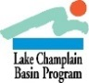

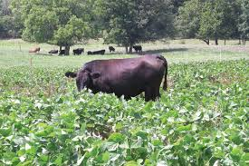
Foraging for alternatives?
Taking a fresh look at Soybeans & Sorghum

We can’t control the weather, but we certainly can manage the soil for better crop yield! By examining soil in open pits for compaction, root zones, soil temperature and moisture retention you can begin to evaluate the conditions for the success of your crops. This field event is intended to provide a comparison of forage crops and to examine the soil that they are growing in.
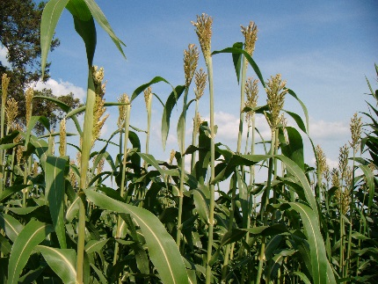
USDA NRCS Soil scientists from the Paul Smith’s Soil Survey office will offer soil information relevant to the site and the Cornell field crop team members will be addressing the key points of annual forage crops- from planter set up to harvest issues.

Note: Our forage plots were planted at the farm on June 10th and will be a living example of the root systems in an annual crop, as we expose them in the pits. Bring your camera, ask your questions!

Date: Wednesday, July 31, 2019
Location: Willsboro Research Farm
Time: 1:30 - 4:00

Guest Speakers
Janella Cruz & Rebecca Fox; USDA- Natural Resource Conservation Service
Kitty O’Neil, PhD, CCA; Cornell Cooperative Extension
Mike Davis; Willsboro Research Farm
Essex County Soil & Water Conservation District

Did you know: In a recent survey of farmers, folks that participated in peer events were more profitable? Read about it in the online magazine, On Pasture. https://onpasture.com/

For more information contact essexswcd@westelcom.com or 518-962-8225

Bring a spoon to enjoy the ice cream!

Sponsored by: USDA, NRCS Soil Science program, Cornell Cooperative Extension,
NEIWPCC, Lake Champlain Basin Program and Willsboro Research Farm.

Agenda
Arrive by 1:30 for a Meet and Greet!

1:30 Introductions

1:40 Background information on the selected annual crops (sorghum and soybeans) at the plot locations and planting conditions

2:00 Soil tables for demonstration of the soil characteristics

2:15 Soil pit examination and discussion of the soil issues at the soil pit

2:50 Discussion at the crop plot: Addressing crop needs, fertility, & yield

3:15 Reviewing equipment calibration and planting tips

3:40 Questions, discussion and ICE CREAM !

